How you can help at home

* Read with your child every day. Talk about favourite stories, characters, and illustrations.
* Talk about the things you see on the way to and from school.
* Talk about school and how much fun Nursery is and what they enjoyed doing.
* Ask about the friends they have made.
* Help your child to be independent e.g. using the toilet, managing clothing and shoes, wiping their own nose and eating with cutlery.

***Using the toilets, pulling up our sleeves to wash hands and staying for lunch are big steps for young children – please practise as lots of encouragement will help!***

Transport Activities

Our first topic is transport. We will be:

* Reading books about travelling.
* Using small world play to understand how we can get to places.
* Taking part in transport role-play activities.
* Singing familiar songs about transport.

Personal, Social and Emotional Development

The nursery children are meeting lots of new friends in school. We will be supporting them to do this by:

* Helping them with sharing resources.
* Doing activities to help children take turns and work together.

This will help children to make friends and play together.

Communication and Language and Literacy

Research has shown that children’s communication and language skills, on entry to school, are a good indicator of future academic success. It is therefore important that both school, and home, work to support the development of solid communications skills. We can do this by:

* Modelling new vocabulary and sentence structures.
* Supporting children to speak in full sentences.
* Speaking to children about anything and everything.
* Using talk to organise play, “Lets go on the bus…I will be the driver”.

Events

* Support us by coming on local trips (Covid 19 allowing) to help us understand our world.
* Please regularly check your emails from us (they may go in your junk box)

Should you have any concerns about your child, please make an appointment, as we cannot always speak to you on arrival.

**The Wheels on the Bus**

Keeping Safe at School

The Nursery can be a busy place, so we are learning to move around safely. We are learning to:

* Use the climbing equipment safely. No toys to go up the slide area.
* Tidying resources away to keep our classroom environment safe.
* Walk in the classroom and run in the garden.

**Please work with us to keep your child safe from COVID-19. Talk to them about thorough hand washing and not putting things in their mouths.**

What you need to bring to school:

* Bring your water bottle every day.
* Make sure you have spare clothes clearly labelled in a bag to go on your childs coat peg.
* Wear shoes with no laces.

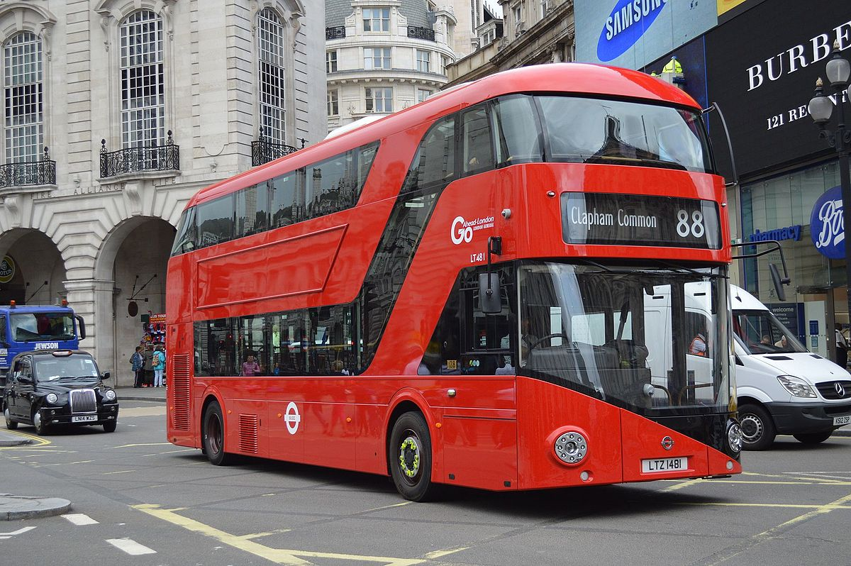

[This Photo](https://en.m.wikipedia.org/wiki/London_Buses_route_88) by Unknown Author is licensed under [CC BY-SA](https://creativecommons.org/licenses/by-sa/3.0/)